Guest Posting Page
I.
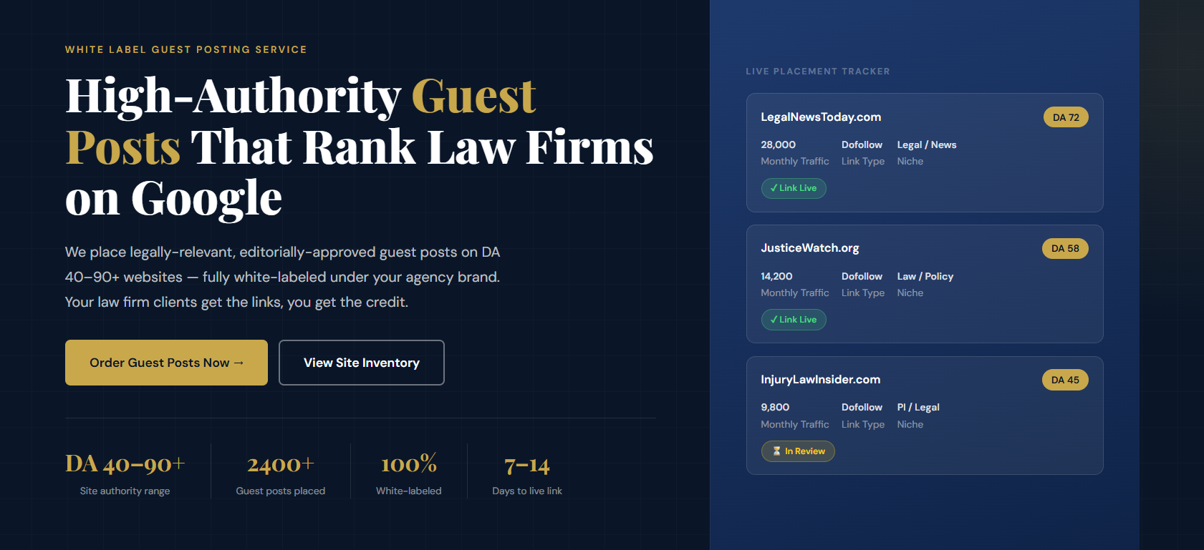
White Label Guest Posting for Legal Agencies

High-Authority Links for Law Firms.
Placed on Sites That Actually Move Rankings.
We secure guest posts on DA 50+ legal publications, real sites, real traffic, real editorial standards, the kind Google trusts and competitors struggle to replicate.
All white-labeled. All yours.
1000+ Clients. 1500+ National & Regional Publishers. 50 States
---------------------------------------------------------------------------------------------------------------
Need a banner image:
Guest posting is one of the fastest ways to move rankings when it's done right.

----------------------------------------------------------------------------------------------------------------------
II.
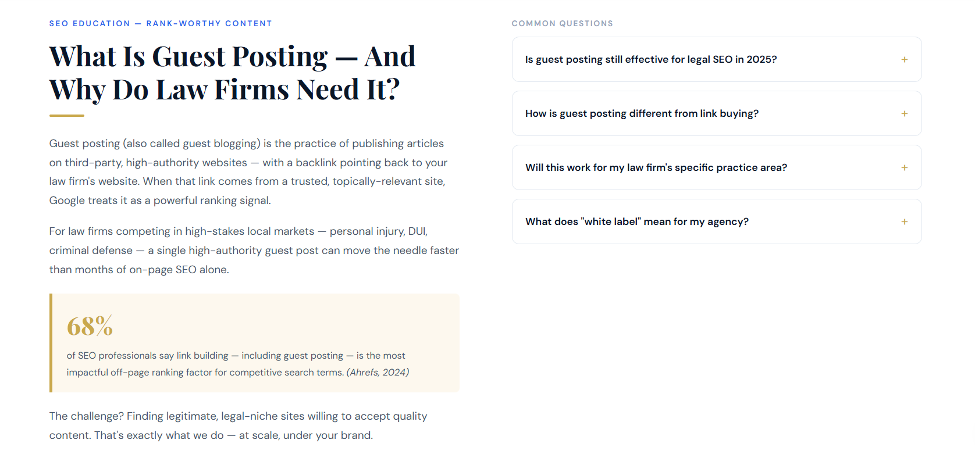
Know What You're Buying

Guest Posting for Law Firms:

What It Is, Why It Works,

and Why Most Agencies Get It Wrong
Guest posting (also called guest blogging) is the practice of publishing articles on third-party, high-authority websites with a backlink pointing back to your law firm's website. Google counts quality backlinks from quality content and relevant sites as a vote of confidence.
The problem most agencies run into is finding quality legal sites that accept it, writers who can clear editorial review, and a process that delivers on time.
That's the gap we, Attorney Rankings, fill in.
68%
of SEO professionals say link building, including guest posting, is the most impactful off-page ranking factor for competitive search terms. (Ahrefs, 2024)
-------------------------------------------------------------------------------------------------------------------
III.
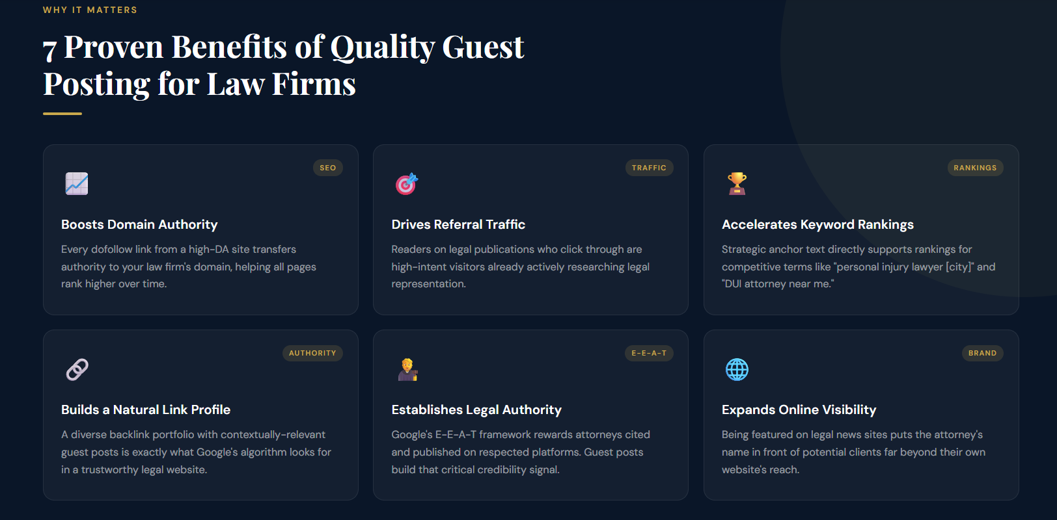
The Real Return on a Guest Post

Six Proven Reasons Guest Posts Work Harder Than Most Off-Page SEO
- Boosts domain authority
Every dofollow link from a high-authority site raises your domain rating. Over time, that rising authority lifts every page they publish.

- Drivers targeted leads, not cold traffic
A well-placed relevant guest post puts you in front of readers who are already in search and connecting mode.

- Accelerate keyword rankings
When anchor text/keyword is chosen strategically, guest posts directly support rankings for the terms you are targeting.

- Builds a quality backlinks profile
A backlink portfolio built on legitimate guest posts looks organic. That's what protects rankings long-term, not a spike of links from dubious sources.

- Strengths legal authority
Attorneys/firms featured across authoritative publications build the kind of E-E-A-T signal that moves them into the top results and in high-value terms.

- Expands online visibility
Guest posts extend the reach to audiences on publications they'd never otherwise appear on, turning strangers into leads.

Need this stats data below:
Top 3
Google results for any keyword have, on average, 3.8x more backlinks than positions 4–10. Backlinks remain one of the clearest separators between the firms that rank and those that don't. (Backlinko, 2023)

-------------------------------------------------------------------------------------------------------------------------
IV.
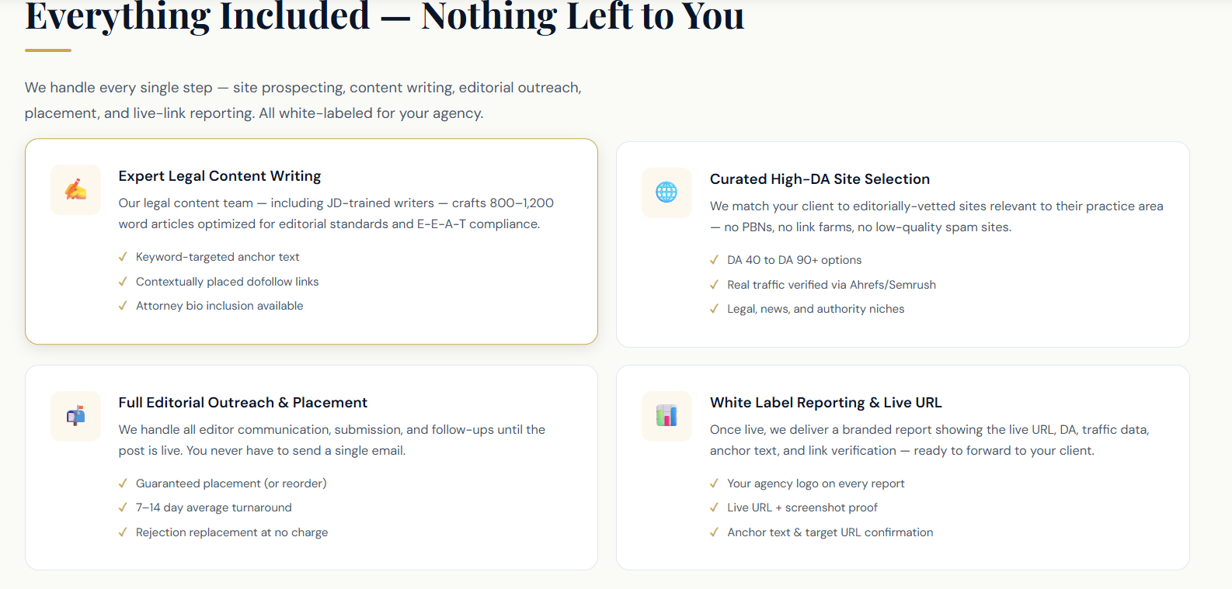
What You Actually Get When You Work with Us
From the First Word Written to the Live Link Delivered,
We Handle Every Step
There's nothing for you to chase, coordinate, or follow up on. You submit the brief. We take it from there.
Expert content pieces written by U.S. legal writers
We write content pieces that add genuine value to the publication's readership, which is exactly why they get approved.
- 500–800+ words per article, written by legal specialists
- E-E-A-T compliant structured for Google's quality evaluators
- Practice area expertise is built into every article with AEO & GEO guidelines
Customized high-DA site section
We don't offer you a list and let you guess. We hand-pick the right site for each order based on DA, traffic, topical relevance, and geographic alignment with your client's market.
- Every site is verified for traffic authenticity before it goes into our inventory
- Option for site preview and approval before submission
- DA verified independently, no self-reported metrics
Placement managed entirely on our end
We submit, we follow up, we handle any editorial notes, and we confirm the go-live date. You hear from us when the link is live, not before, not in between.

- Guaranteed placement or we reorder at no cost
- 15–30 day standard turnaround on all orders
- Live link confirmation sent the day it goes up

Reports that carry your brand and your credibility
We send a fully branded report showing the live URL, site DA, monthly traffic, anchor text used, and link verification. Forward it straight to your client.

- Fully white-labeled, your branding on every report
- Live URL with screenshot confirmation
- Full placement data that your client can verify

--------------------------------------------------------------------------------------------------------------------------
V.

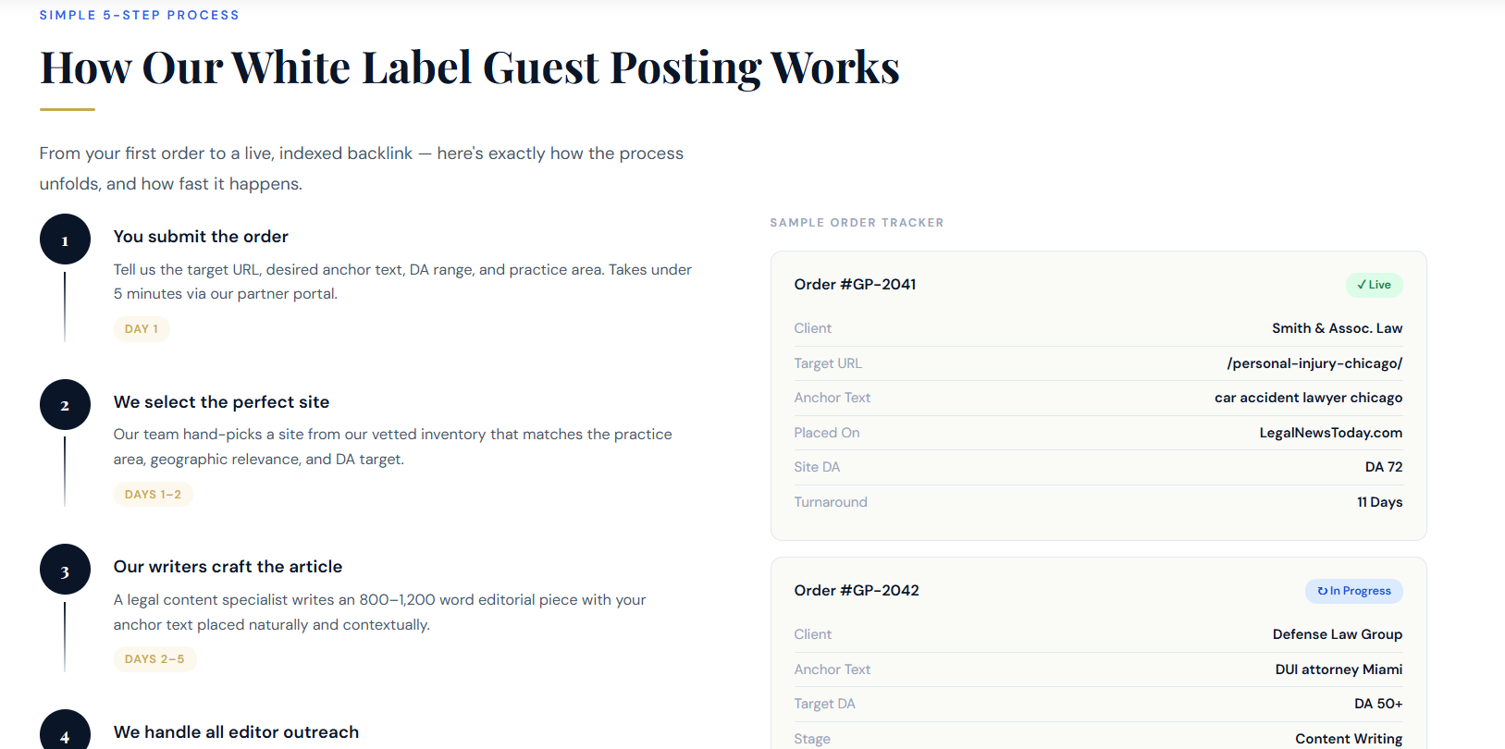

Our Simple 5-Step Process
How Our White Label Guest Posting Works
We know "we handle everything" sounds good, but it means nothing without specifics. So here are our specifics.
1. You submit the order
Tell us the target URL, desired anchor text, DA range, and practice area. You get a confirmation and an estimated delivery window.

2. We find the right site
Our team hand-picks the suitable site that matches the practice area, geographic relevance, and DA target. You get a chance to approve the needed from your side and choose.

3. The content gets written and reviewed internally
A legal content specialist writes a 500-800+ word editorial piece with your anchor text placed naturally and contextually.

4. We handle the editorial outreach back-and-forth
Our team manages submission, communication, and revisions until the post is accepted and scheduled for publication. We only contact you if something genuinely requires your input, which it rarely does.

5. Live URL + branded report delivered
The post goes live. We send you a white-labeled report with the URL, site data, and link confirmation all ready to forward to your client.
--------------------------------------------------------------------------------------------------------------------------
VI. 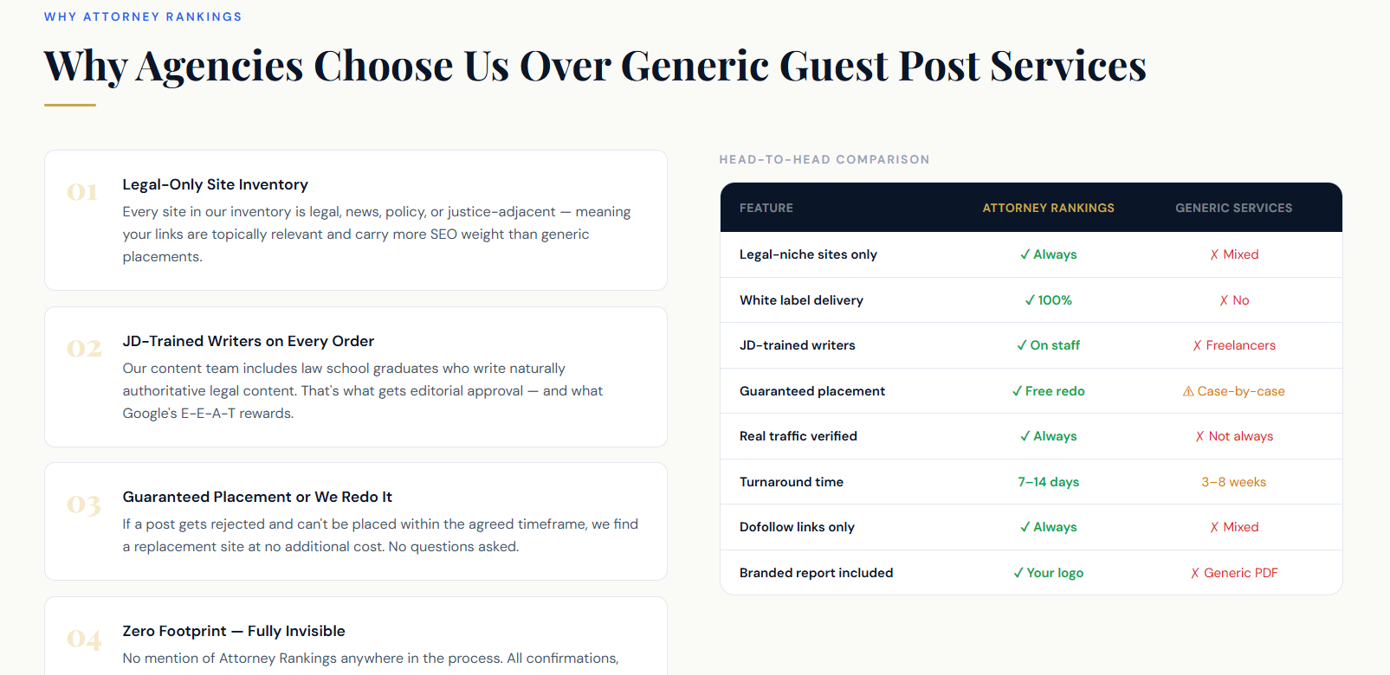
Note: Using the comparison table, and its content… just one alteration turnaround time 25-30 days for Attorney Rankings

Why Attorney Rankings

There Are Dozens of Guest Post Services.

Here’s What Separates Ours
Feature | Attorney Rankings
Relevant-niche sites and magazines only | ✓ Always
White label delivery | ✓ 100%
JD-trained writers | ✓ On staff
Guaranteed placement | ✓ Free redo
Real traffic verified | ✓ Always
Turnaround time | 20-30 days (depending upon the order)
Branded report included | ✓ Yes

-------------------------------------------------------------------------------------------
VII.
We've Built Guest Posting Campaigns Across Every Major Practice Area and We Know What Works in Each One
We've built enough expertise in each one to know what sites work, what content clears editorial, and what anchor text strategy moves the rankings.
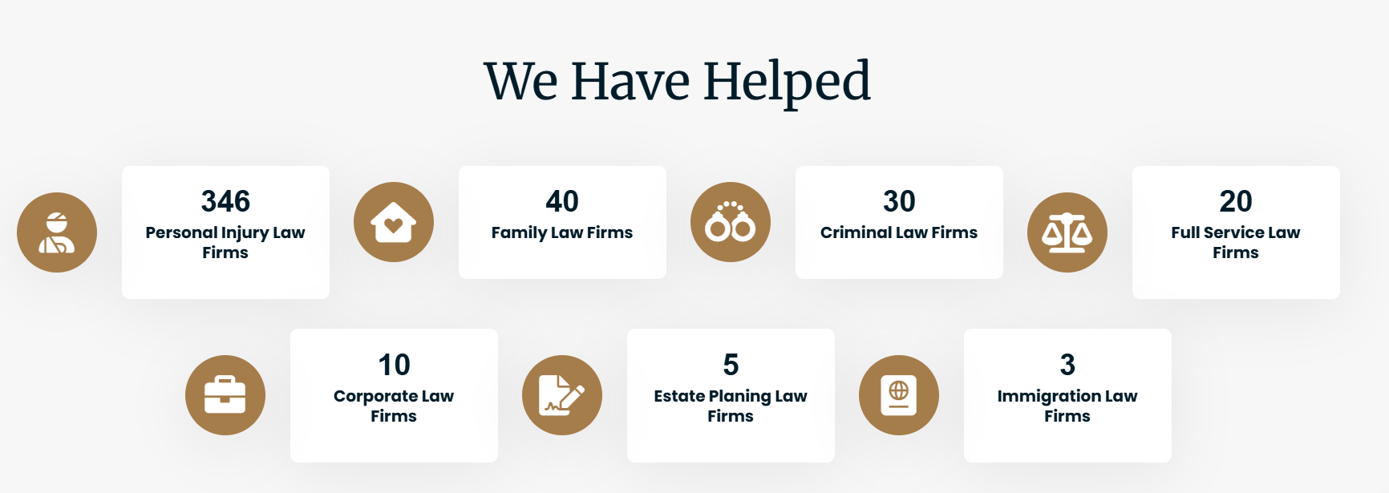
-------------------------------------------------------------------------------------------------------------------------
VIII.
From the Agencies That Placed the Orders

What It Feels Like to Work with a Guest Posting Partner That Actually Knows Legal SEO
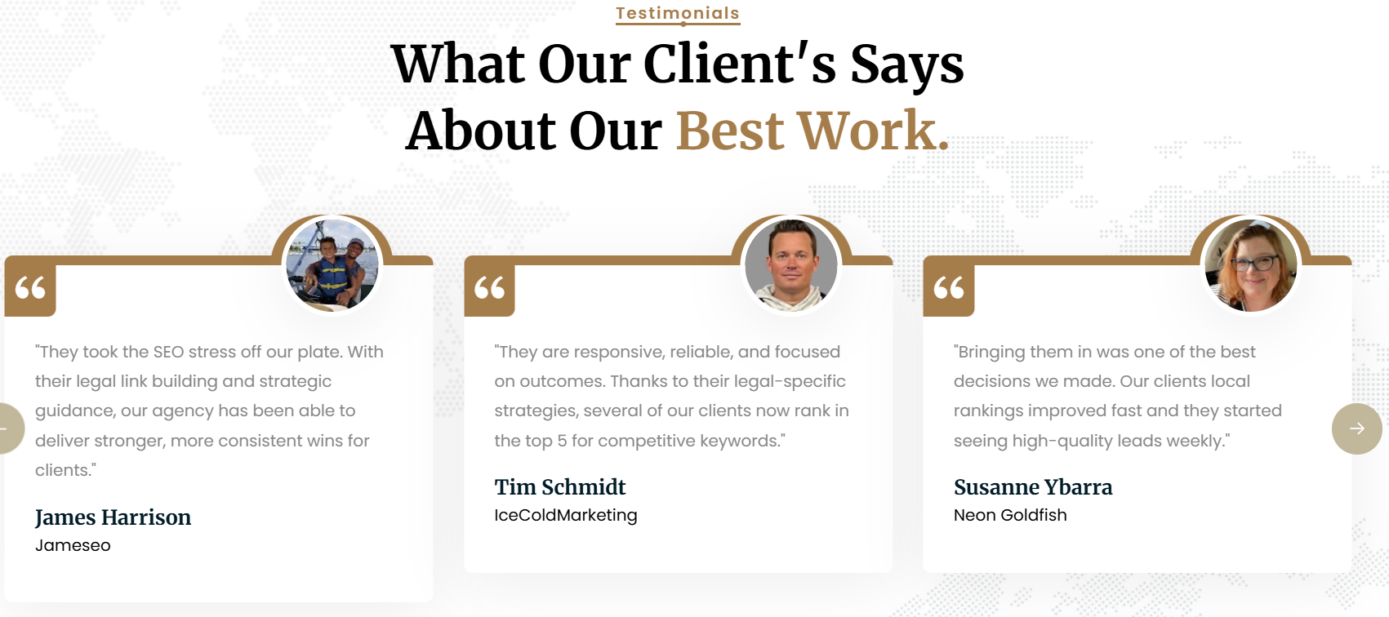

-----------------------------------------------------------------------------------------------------------------------
IX.
FAQs
What DA range do your sites fall in?
DA 20+ to DA 50+, depending on the package tier. We don't inflate DA metrics; every site is verified independently at the time of placement.
How long does a placement actually take?
15–30 business days is our standard window. 1-20 posts in 15 days and up to 300 posts in 30 days. We'll give you a realistic estimate at the time of order.
Can I see the site before you submit the article?
Yes, this is available. We present you with one or two site options before we proceed, and you confirm.
Is there a minimum number of orders I need to place?
No minimum. You can place a single order to test the process. Agencies that are happy, which is most of them, move to monthly bulk orders, but there's no requirement to commit to volume before you're ready.
----------------------------------------------------------------------------------------------------------------
X. CTA banner

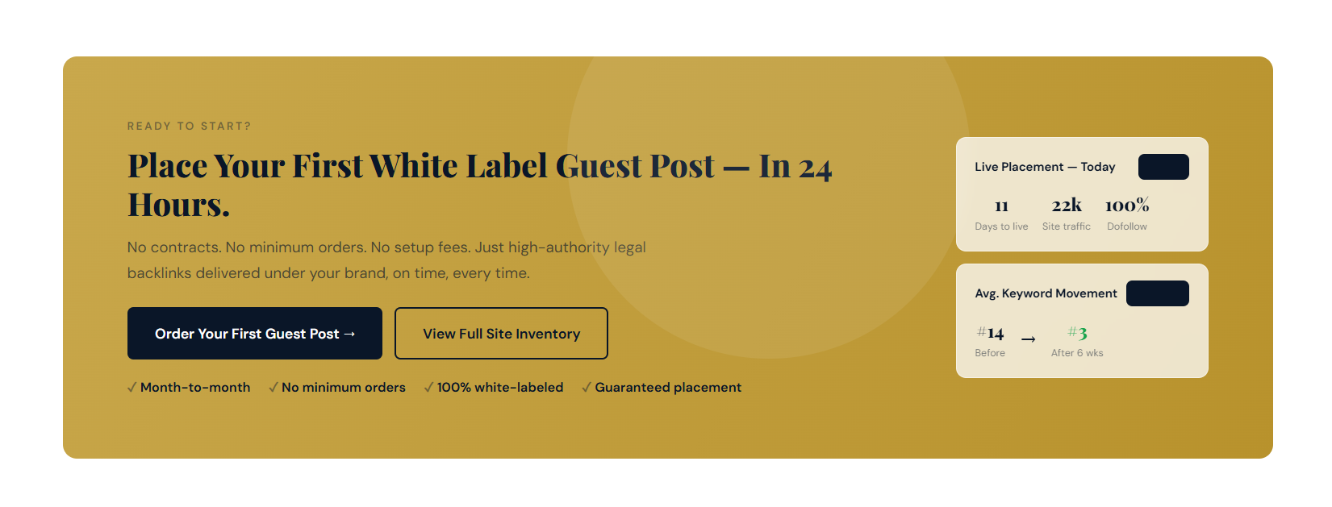
Ready to Start?

Place Your First White Label Guest Post.
No contracts. No minimum orders. No setup fees. Just high-authority legal backlinks delivered under your brand, on time, every time.
CTA button: Order Your First Guest Post
Month-to-month. No minimum orders. 100% white-labeled. Guaranteed placement
x-----------------------------------------------------x

